PROFILE
Name | : | Dr. P.Geetha | 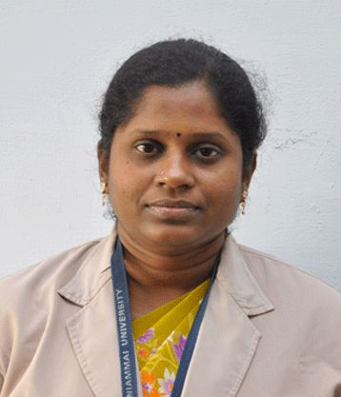
Designation | : | Assistant Professor
Department | : | Mathematics
Educational Qualification | : | M.Sc., M.Phil., Ph.D
Area of Interest | : | Number Theory  Differential Equations
Teaching Experiences | : | 14 years
Number of Papers Published | : | - Scopus Indexed Journals : 2  - International : 4  - National : 2
Publications : | : | Scopus Indexed :  - Unitary Partition Algorithm in Shortest Path Problems, International Journal of Recent Technology and Engineering (IJRTE) ISSN: 2277-3878, Volume-8 Issue-3, September 2019.  - Solving Assignment Problems using Consecutive Integers with Residue Partitioning, International Journal of Innovative Technology and Exploring Engineering (IJITEE) ISSN: 2278-3075, Volume-8, Issue-10S, August 2019.  International:  - Consecutive Odd Partitioning of Integers, Global Journal of Scientific and Research Publications, Volume 1, Issue 6, PP 15 – 17, May 2021.  - The triple and quadruple complete partitions of Integers, Bulletin of Pure and Applied Sciences, Vol. 38E (Math & Stat.), No.1, 2019. P.356-358, Print version ISSN 0970 6577, Online version ISSN 2320 3226, DOI: 10.5958/2320-3226.2019.00038.9.  - Prim’s Algorithm Combined With Partitions, International Journal of Scientific Research and Review, Volume 8, Issue 5, 2019, ISSN NO: 2279-543X.  - Shortest Path Problems Using Complete Partitions, International Journal of Applied Engineering Research ISSN 0973-4562 Volume 13, Number 12 (2018) pp. 10478-10481 © Research India Publications. http://www.ripublication.com
National:
- On Fuzzy bridges, The PMU Journal of Humanities and Sciences,
Vol.2, No.1, (Jan – Jun 2011), pp.89-93.
- Fuzzy cutnodes, The PMU Journal of Humanities and Sciences,
Vol.4, No.2, (July – December 2013), pp.55-60.
Google Scholar Link | :
  https://scholar.google.com/citations?view_op=list_works&hl=en&user=vQbnVnoAAAAJ
Seminars/ Conferences/ Workshops organized | : | - Co – Convenor of One day Seminar on Statistics and its applications in Engineering, PMU, 18.04.2012  - Co – Convenor of One Week State Level Workshop on CRACKING COMPETITIVE EXAMS CSIR-UGC NET / SET, PMIST, 23rd to 28th SEPTEMBER, 2019.  - Co – Convenor of Online Webinar on Brain Activation Techniques and Memory Technique for Easy Learning, on 30.09.2021, PMIST.
Papers Presented | : | - P. Geetha, 7, 8, 9, 10 - tuple Complete Partitions of Integers, International Conference on Advanced Research in Mathematical Sciences (Online), Sri Manakula Vinayagar Engineering College, Pudhucherry,  on February 24 & 25 2021.  - P. Geetha and A. Gnanam, Solving Assignment Problems using Consecutive Integers with Residue Partitioning, TNSCST sponsored International Conference on Applications of Mathematics in Science and Technology, AAA College of Engineering and Technology, Sivakasi, on 25th& 26th July 2019.  - P. Geetha and A. Gnanam, The triple and quadruple complete partitions of Integers, International Conference on Mathematical Methods and Computation, PG & Research Department of Mathematics, Jamal Mohamed College, Tiruchirappalli – 620 020, on 20th& 21st February 2019.

Conferences/ Workshops/ Seminars/ FDP attended | : | - Conferences  - International - 06  - National - 02  - Workshops - 13  - Seminars - 26  - FDP attended – 10  - SWAYAM online Courses - 01
Contact Address |  | Dr. P. Geetha,  Assistant Professor, Department of Mathematics,  Periyar Maniammai Institute of Science & Technology,  Periyar Nagar, Vallam, Thanjavur – 613 403.  geethamaths@pmu.edu

